Cairo University  
Faculty of Computers and Artificial Intelligent

**CS251**

**Software Engineering I**

Parking system

Software Design

|  |  |
| --- | --- |
| **ID** | **Name** |
| 20200326 | عزالدين على خليل |
| 20200599 | نغم حسن ابو الفتح |
| 20200076 | اسراء محمد عبدالستار |
| 20200578 | مينا صفوت |

6/2022

Contents

Team 3

Document Purpose and Audience 3

System Models 3

I. Class diagrams 3

Important Algorithm 4

II. Sequence diagrams 5

Class - Sequence Usage Table 6

Policy Regarding Plagiarism: 7

# Team

|  |  |  |  |
| --- | --- | --- | --- |
| **ID** | **Name** | **Email** | **Mobile** |
| 20200326 | عزالدين على خليل | Ezz500549@gmail.com | 01023773667 |
| 20200599 | نغم حسن ابو الفتح | naghamhassan04@gmail.com | 01147272506 |
| 20200076 | اسراء محمد عبدالستار | esrramhumd@gmail.com | 01112306935 |
| 20200578 | مينا صفوت | 11410120200578@stud.cu.edu.eg | 01285104997 |

# Document Purpose and Audience

* this document contains deep insight into the software
* it helps the developer to know how the software can run
* it helps him to develop the software easily
* only the developer can read this because he only can understand this document

# System Models

## I. Class diagram

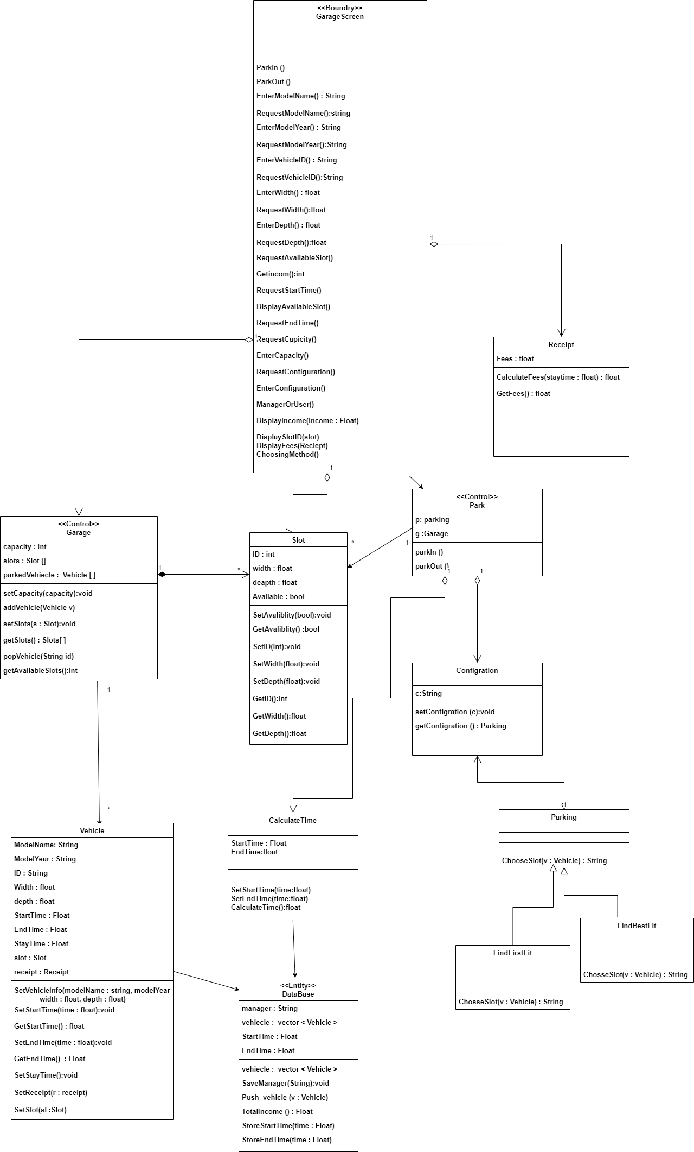

* **Classes description:**

| **Class ID** | **Class Name** | **Description & Responsibility** |
| --- | --- | --- |
| 1 | Parking | a class that has the functions to choose the method for the garage |
| 2 | Vehicle | a class that story the vehicle information |
| 3 | CaluclateTime | a class that gets start time and end time and calculate the stay time |
| 4 | Slot | stores all the information about the slots |
| 5 | GarageScreen | (Boundary class) It helps the user to communicate with the system |
| 6 | Garage | )control class)Responsible for interactions within the system |
| 7 | Park | has the main functions which is parkin and parkout |
| 8 | Receipt | calculates the total fees and returns it to the driver |
| 9 | DataBase | (Entity Class) stores all the information about the grage and the vehicle |
| 10 | Configration | Story the Configration |

### Important Algorithm

* **findFirstFreeSpace method:**

**the method implements linear search Starting from the leftmost element of free slots array and one by one compare vehicle's width and vehicle's depth with each slot If the slot's dimensions greater than or equal the vehicle's dimensions, return the slot.**

**If the vehicle's dimensions less than the slot's dimensions, return null**

## II. Sequence diagrams

### (ID->1)

### 

### (ID->2)

### 

**(ID->3)**

### 

### Class - Sequence Usage Table

| **Class Name** | **Sequence Diagrams** | **Overall used methods** |
| --- | --- | --- |
| GarageScreen | 1,2,3 | ChosseMethod,EnterConfigration, requestConfigration,parkout, requestAvaliableSlot,DisplaySlotID,EnterSlotID,RequestSlotID,DisplayFees,Parkin,RequestModualName, RequestModualYear, RequestModualID,  RequestVehicleWidth, RequestVehicleDepth  EnterModelName, EnterModelYear, EnterModelID  EnterVehicleWidth, EnterVehicleDepth |
| Garage | 1,3 | getSlot,getAvailableSlot,ChooseMethode |
| Vehicle | 1,2 | SetVehiceInfo,SetStartTime,GetStartTime,SetEndTime |
| Parking | 3 | ChooseSlot |
| park | 1,2,3 | ParkIn,ParkOut |
| DataBase | 1,2 | StoreEndTime,StorStartTime,Push_vehicle |
| Reciept | 2 | calculateFees,GetFees |
| ClaculateTime | 2 | SetStartTime,SetEndTime,CalculateTime |
| configration | 3 | SetConfigration,GetConfigration |